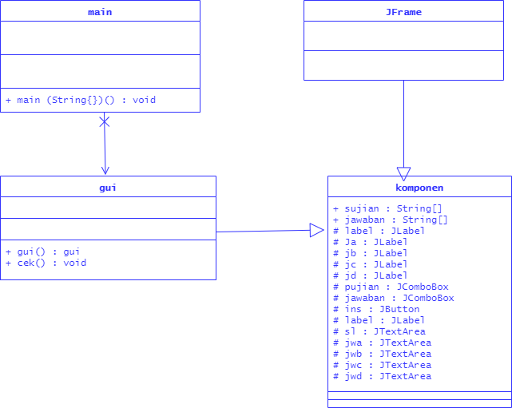

Keterangan Source Code :

------------------------------------------------------------------------------------------------------------------------------------------------------------------------------------------------------------------------------------------------------------------------------------------------------------------------------------------------------------------------------------------------------------------------------------------------------------------------------------------------------------------------------------------------------------------------------------------------------------------------------------------------------------------------------------------------------------------------------------------------------------------------------------------------------------------------------------------------------------------------------------------------------------------------------------------------------------------------------------------------------------------------------------------------------------------------------------------------------------------------------------------------------------------------------------------------------------------------------------------------------------------------------------------------------------------------------------------------------------------------------------------------------------------------------------------------------------------------------------------------------------------------------------------------------------------------------------------------------------------------------------------------

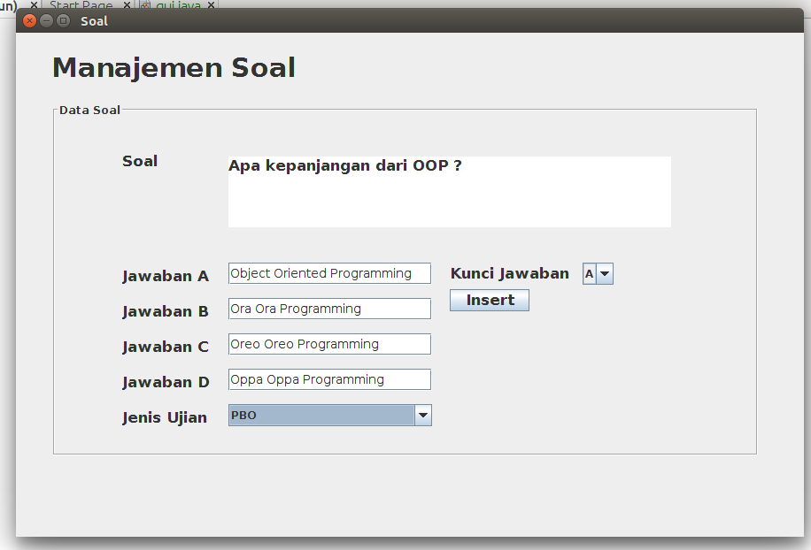

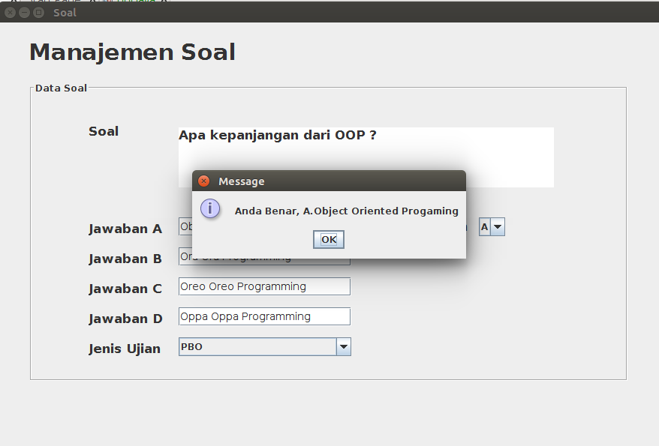

Keterangan Source Code :

---------------------------------------------------------------------------------------------------------------------------------------------------------------------------------------------------------------------------------------------------------------------------------------------------------------------------------------------------------------------------------------------------------------------------------------------------------------------------------------------------------------------------------------------------------------------------------------------------------------------------------------------------------------------------------------------------------------------------------------------------------------------------------------------------------------------------------------------------------------------------------------------------------------------------------------------------------------------------------------------------------------------------------------------------------------------------------------------------------------------------------